Team: Eco warriors
Subject : science video
Best presentation – silver medal
Members :
Sara Sadeghi>coordinator
Dorsa Sharifi
Mahya Barzegari
School : Farzanegan 7
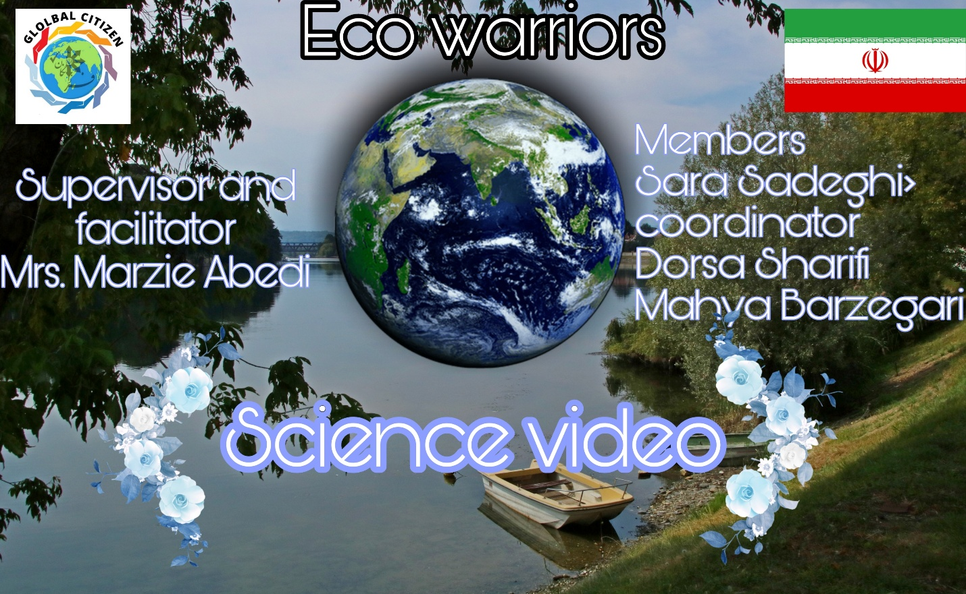
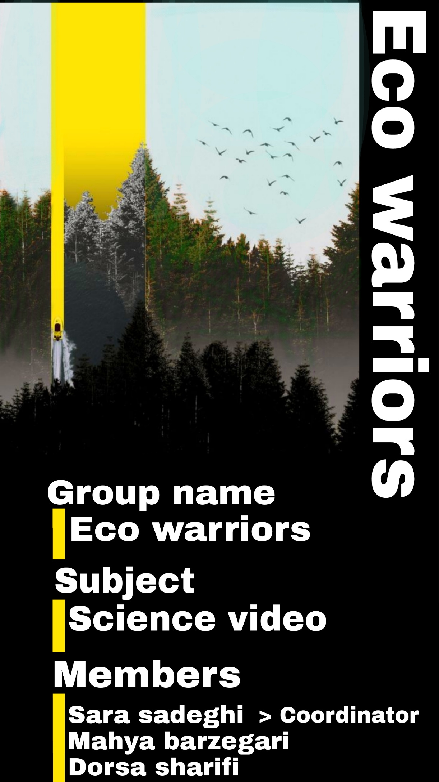
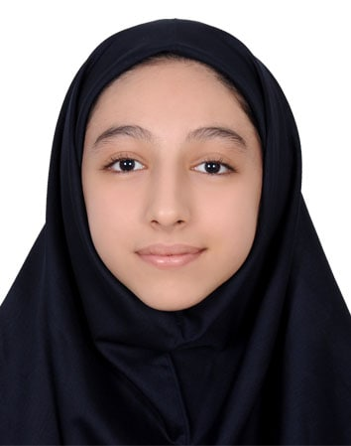
Sara Sadeghi :

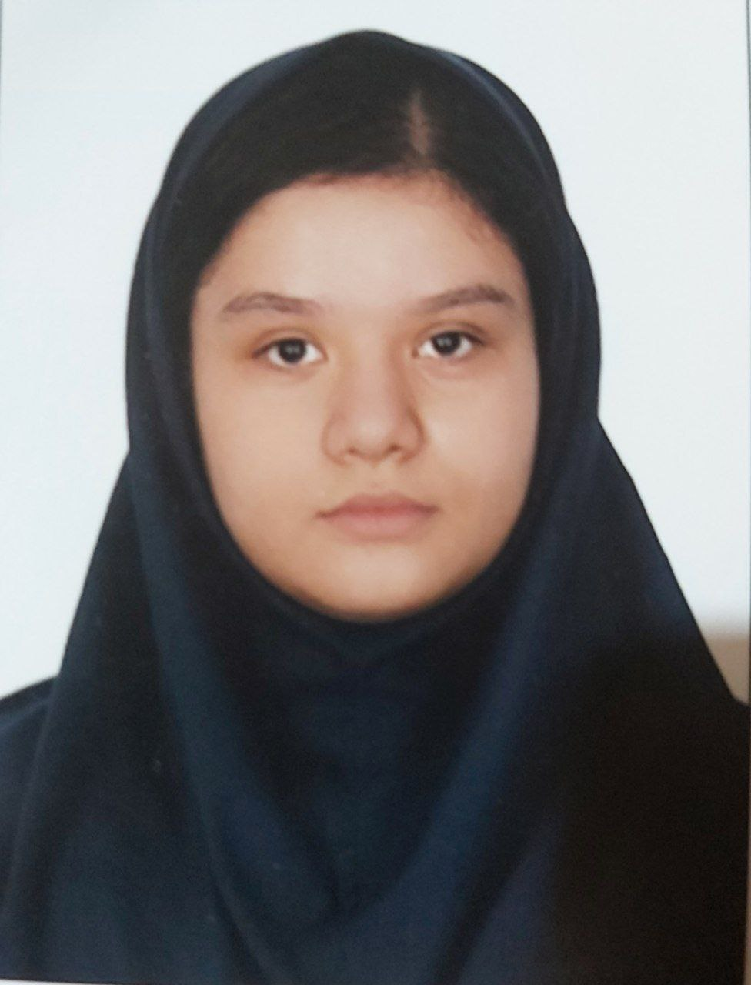
Dorsa Sharifi :
Mahya Barzegari :
